Pointers Assignment

Write a program in C++ to declare an integer variable, store its address in a pointer, and display both the value of the variable and its address using the pointer.

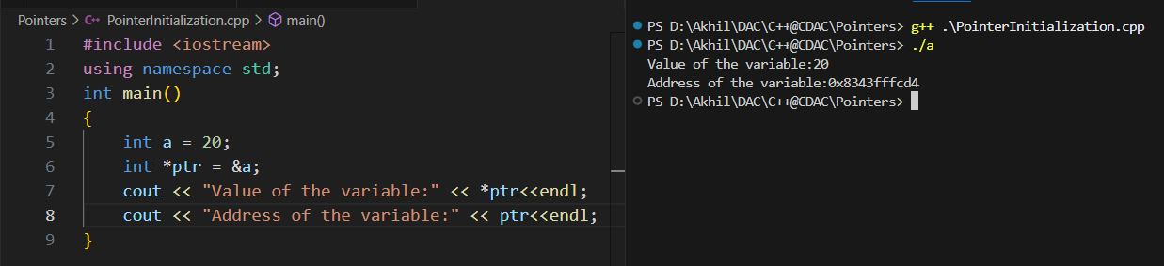

Write a program in C++ to create an array of 5 integers. Use a pointer to traverse the array and print all elements using pointer arithmetic.

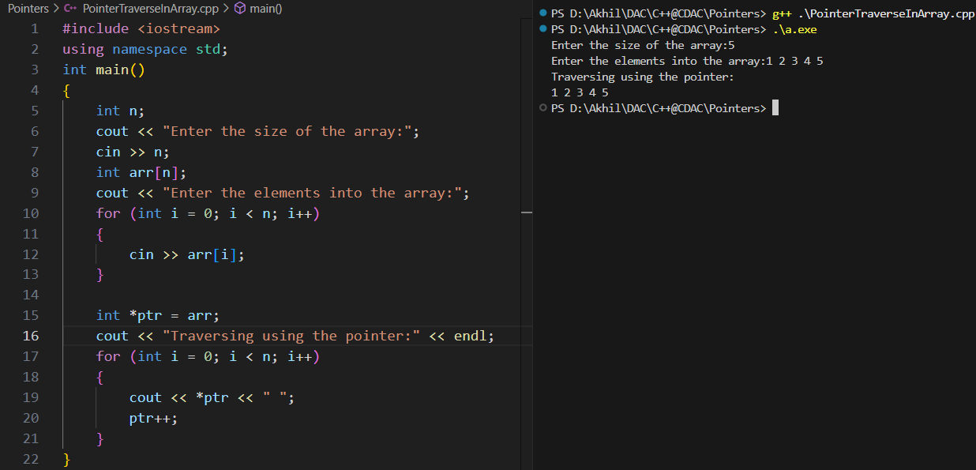

Write a program in C++ to swap two numbers using pointers.

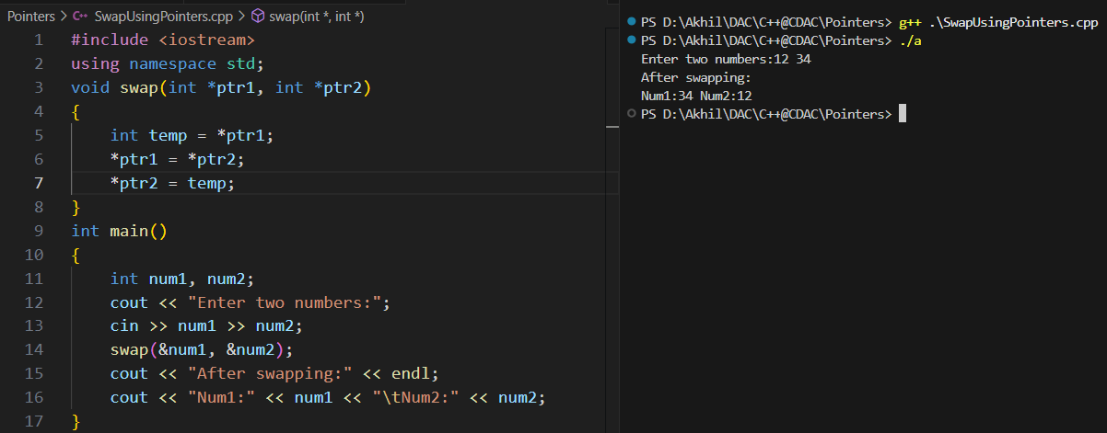

Write a program in C++ to dynamically allocate memory for an array of 5 integers using a pointer, take input from the user, and display the array elements.

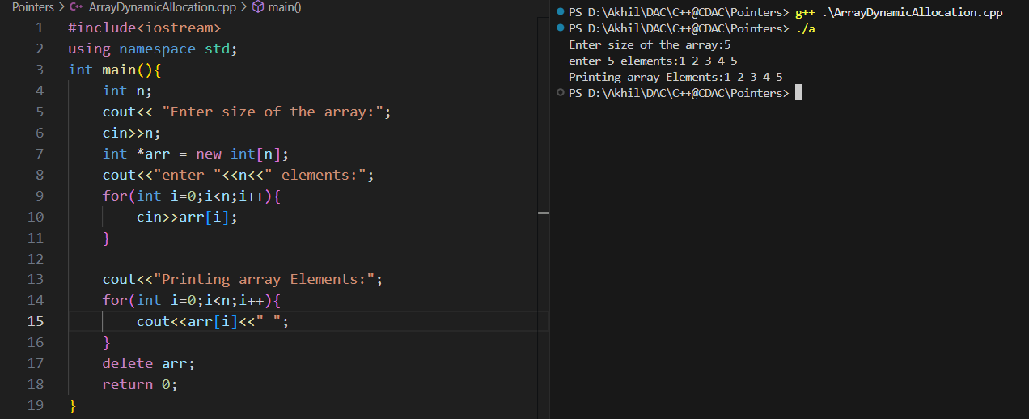

Write a program in C++ to pass a pointer to a function that updates the value of a variable.

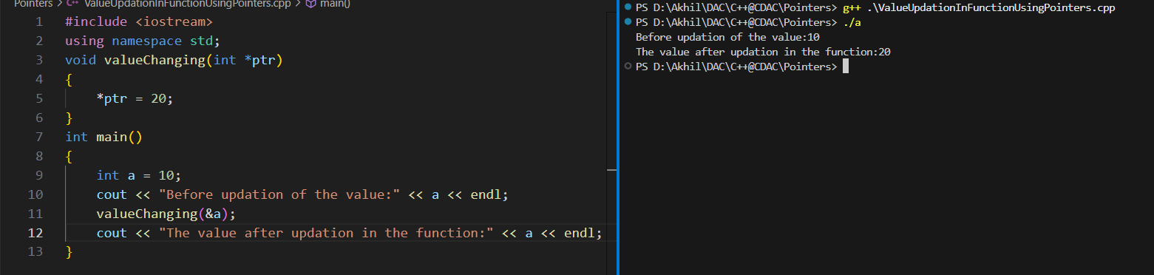

Write a program in C++ to count the length of a string using a character pointer (without using built-in functions like strlen).

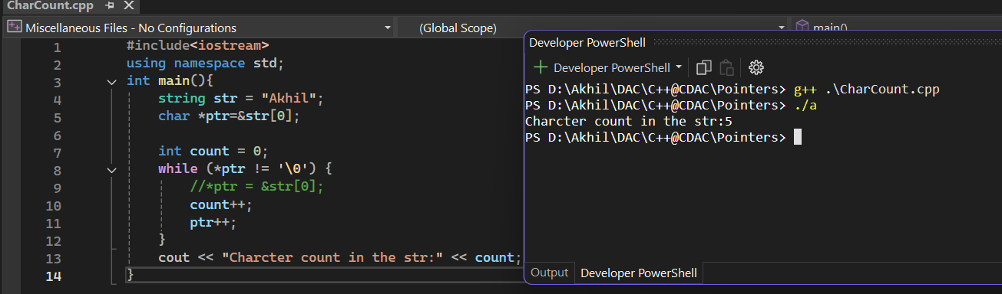

Write a program in C++ to dynamically allocate memory for a single integer using new, assign a value, display it, and then free the memory using delete.

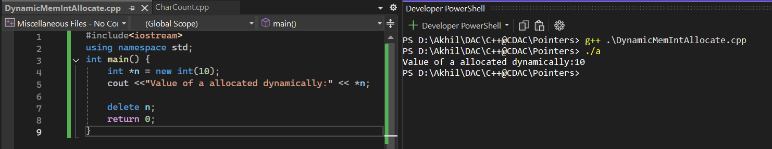

Write a program in C++ to create an array of 5 integers using new, take input from the user, display the array elements, and then release the memory using delete[].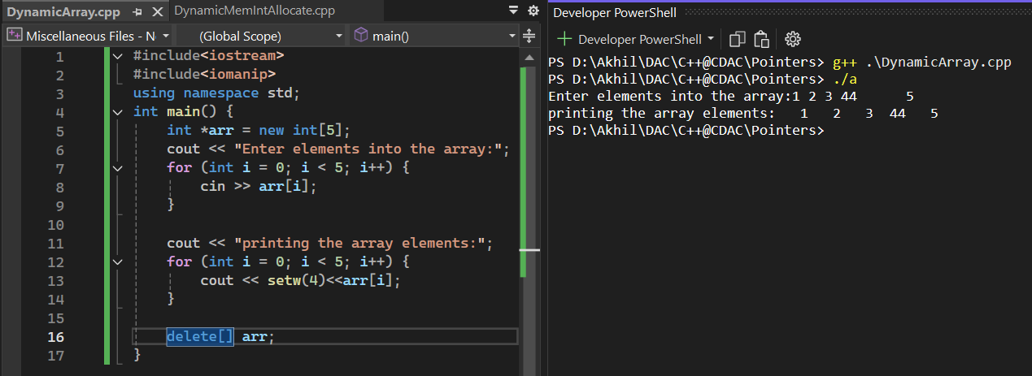

Write a program in C++ to create a 2D array (matrix) dynamically using new. Take input for rows and columns from the user, fill the matrix, display it, and free memory using delete[].